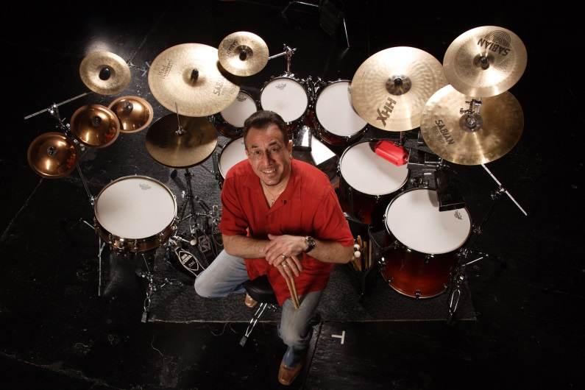

BOBBY SANABRIA has performed with a veritable Who's Who in the world of jazz and Latin music, as well as with his own critically acclaimed ensembles. His diverse recording and performing experience includes work with such legendary figures as Dizzy Gillespie Tito Puente, Ray Barretto, Candido, Paquito D'Rivera, Charles McPherson, Mongo Santamaria, Chico O'Farrill, Henry Threadgill, and the Father of Afro-Cuban Jazz, Mario Bauzá (as his drummer for eight years in the Mario Bauzá Afro-Cuban Jazz Orchestra). Featured on numerous Grammy®-nominated albums, including The Mambo Kings soundtrack, Bobby is also a multi-mainstream-Grammy® and Latin Grammy® nominee with his own big band and student ensembles as well as a repeat winner of the Jazz Journalists' Association Award for Best Percussionist in 2011. His 2012 album, "Multiverse" received two Grammy nominations for Best Latin Jazz Album of the Year and Best Instrumental Arrangement. A new CD, “Qué VIVA Harlem” will be released in 2014. Some Bobby Sanabria Big Band performances include a record-setting 20,000 people at Lincoln Center's Out of Doors Festival, a headlined sellout for the famous Apollo Theater's historical celebration, "From Havana to Harlem, 100 YEARS OF MARIO BAUZA'” and two packed-house concerts at JAZZ at Lincoln Center’s Rose Theater as well as performing and representing Latin Jazz at the first worldwide UNESCO Day of Jazz in 2012 headed by Herbie Hancock for the United Nations and the Thelonius Monk Institute. Recognized for his work in radio and television, including award-winning documentaries for PBS, BRAVO, and The Smithsonian, he is a frequent guest on "NPR This Weekend" and was consultant and featured artist in the four-part documentary "Latin Music U.S.A." broadcast nationwide for PBS and the BBC. A leader in the Afro-Cuban and jazz fields as a drummer and percussionist, he is considered one of the world's foremost performers, educators and articulate scholars of la tradicion living today. He has been featured in the NEW YORK TIMES, DRUM!, MODERN DRUMMER, DOWNBEAT, and JAZZTIMES publications to name a few and was honored in 2006 with a permanent NYC street dedicated to him on the renowned Bronx Walk of Fame in recognition of his work and contributions that have made a difference throughout the world. A graduate of the Berklee College of Music and a recipient of its prestigious Faculty Association Award, he is a professor at the Manhattan School of Music and the New School University in NYC in the jazz and contemporary music programs, directing Afro-Cuban jazz orchestras at both institutions, receiving two Latin Grammy nominations for recordings with the MSM Afro-Cuban Jazz Orchestra. Bobby proudly endorses Tama Drums, Latin Percussion, Remo, Sabian Cymbals, and Vic Firth Sticks and Mallets.

